How to Create an ABN for Your Club

Introduction
This guide has been developed to help clubs create an ABN (Australian Business Number). Firstly, an ABN is a unique 11-digit number that identifies a business to the government. For clubs, the importance of an ABN is so that invoices can be sent to other businesses instead of filling out other forms.
This guide is broken up into two parts:
- Creation of ABN for clubs
- Changing over of ABN details for incoming executive team
An ABN for a club only needs to be created once. Each year it is the responsibility of the outgoing and incoming executive team to handover and change the details to suit the new team.

Creation of ABN
Firstly, head to the ABR (Australian Business Registry) website and hit the “apply or reapply for an ABN”. This will open you up into a new window. It is important to read the privacy statement before moving onto the next step.
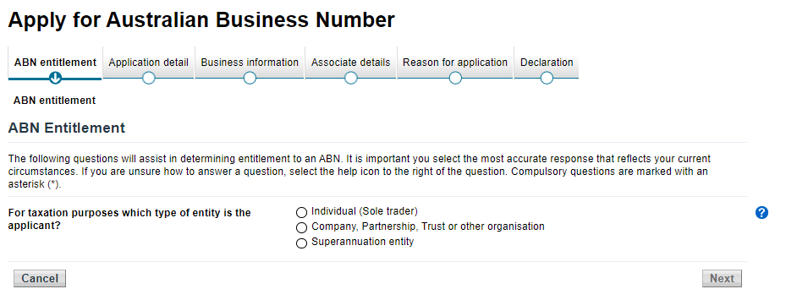
You will now see this on the screen. For this step, all clubs falls under the “company, partnership, trust or other organisation”.

The next step is important. If you are an unincorporated club, select the “other unincorporated entity” in the drop-down box then keep following these instructions.

Select the following prompts from the options.
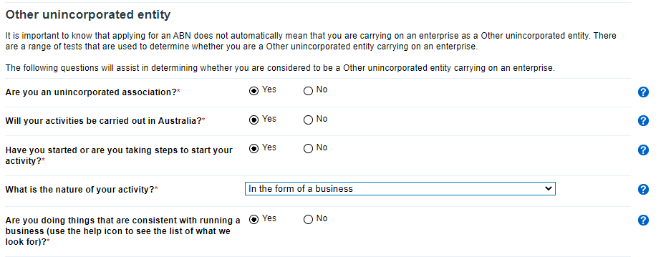
The next part is about the club. If the club does not have an ABN, follow the below steps.
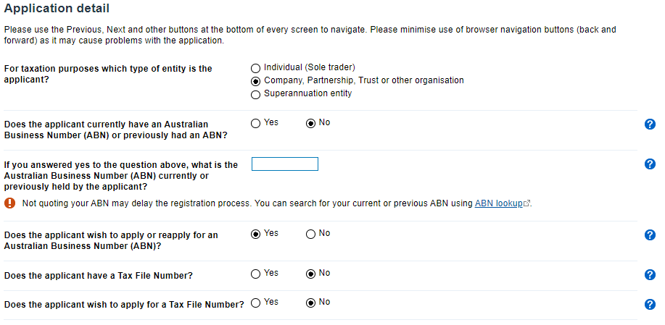
Again, complete the following responses.
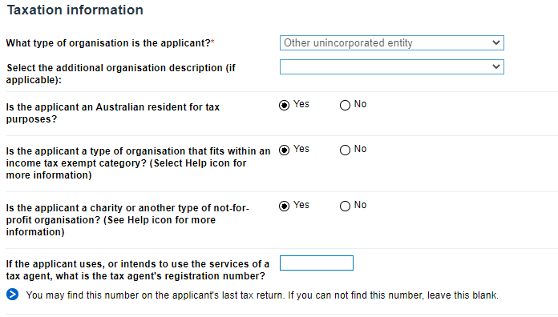

Include your clubs name here.

In the next step, the date you are applying on will already be automatically as the first answer which you can leave there. The second question should be left blank, unless the club intends to be disaffiliated within 3 months (hope not). Third question is “no”, as clubs are not owned or controlled by the government. Fourth question, type into the box “university”, which will prompt the fifth box to find all answers with that involved. The category to choose in this question is “university club operation”.
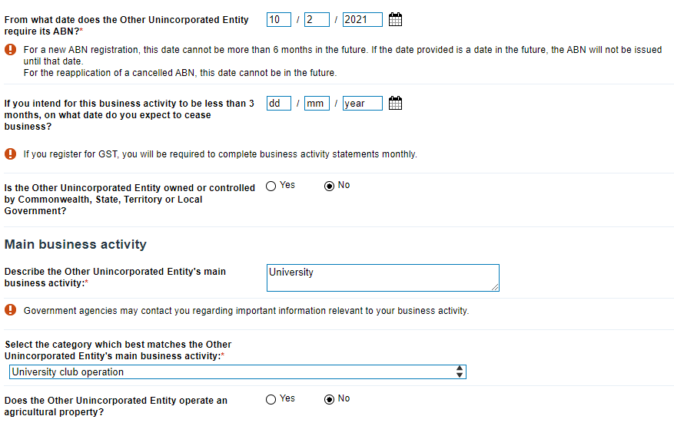

Following this, the step is asking for address details. In the address box, insert the below address for business.
Level 4 Building 21 A UQ Union Complex
University of Queensland
St Lucia, QLD
4072
Keep the box ticked of different postal address if you would like anything to be sent to elsewhere, this will be in the next step. Add in your clubs email address as this will be the main point of contact. Add in a phone number of an executive, and then repeat the email address.
In the next step, this is where you can add in a different postal address.
Next stage is to include the personal details of your executive. It is recommended that at least two people are included, but no more than three. Add in all the relevant details for the authorised people.

Following on, the people that have been added in as authorised contacts, now must be added in as associates. Follow the prompts to add at least one person in, as for unincorporated clubs will only need a minimum of one person. NOTE: the person applying will need their tax file number handy, or else the application will be rejected. The person should tick the “office bearer” box and complete with their details.
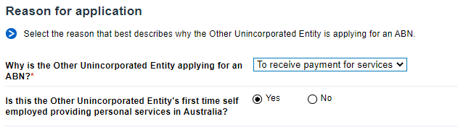
OR
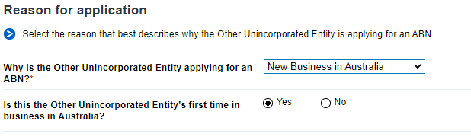
The last step is to declare that everything is correct. If you think everything is correct, someone needs to input their details and declare. Then hopefully the next stage will be a nice green tick with an approval and your clubs new ABN number.

Thank you to Sam McMah and the Thongs society for creating and sharing this guide.

