Handing Over ABN to incoming Exec

Both execs are required to have a My Gov ID account (this is separate to your My Gov account).
https://www.mygovid.gov.au/

- Create My Gov ID and Link business (link club ABN) if you haven’t already done this
- Add user (new executive) on My Gov ID
- Log into ABR website and ‘update ABN details’
- Under contacts tab select yes - delete contact on your current exec and yes – add contact
- Then, under associates tab ADD associate (new executive)
- Once new exec is added, under associates tab select and delete current executive
- Still on the associates tab select update position held on your new exec and make them ‘office bearer’
See Below for a Step by Step Guide
- If you are the current executive and haven’t already (it was suggested to do this at the time of setting up your ABN / you would have been required to do it when handing over from an old

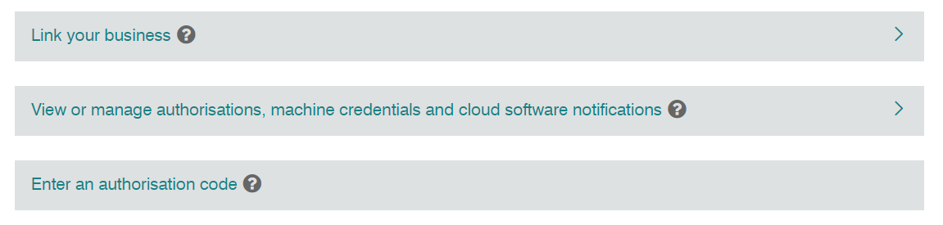
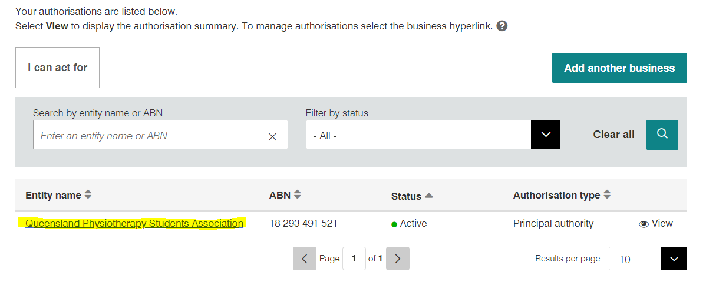

- Once you have linked the business you can add and remove users (this is a two-part process, you currently need to remove / add here on My Gov ID and also through the ABR website. FIRST Add your new user (new executive) on My Gov as an Administrator with FULL access (this will be a question while adding user).
Their status will change to pending, you will then need to remove your principal user (this should be your current exec) through the ABR website first, then come back to My Gov ID and you will then be able to remove them.
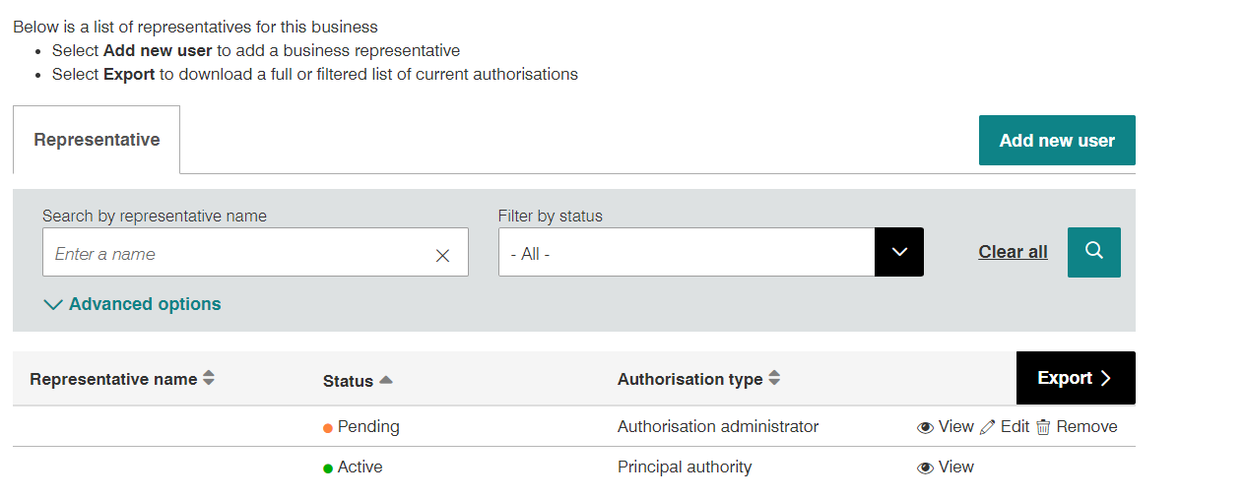

- Go to the ABR (Australian Business Register) and select ‘update your ABN’ https://www.abr.gov.au/business-super-funds-charities/updating-or-cancelling-your-abn/update-your-abn-details
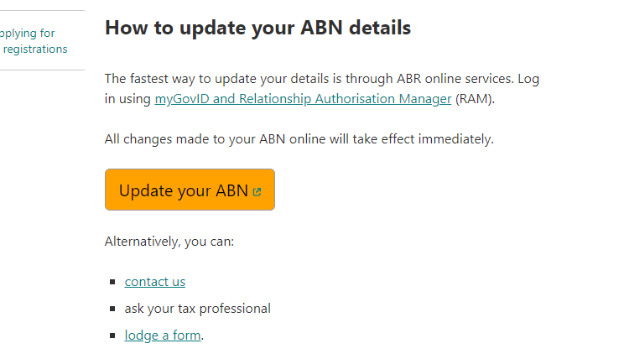

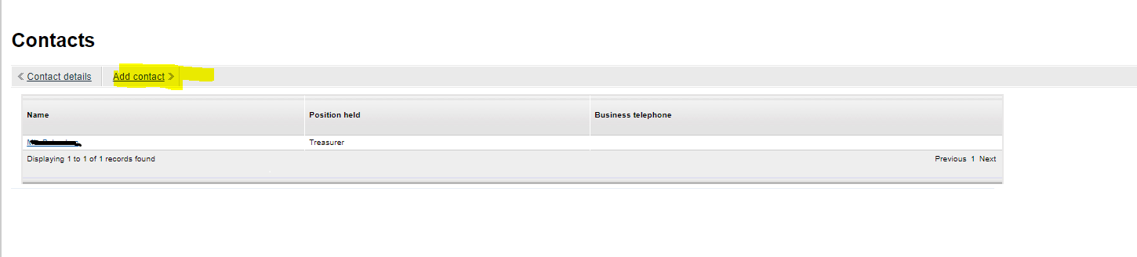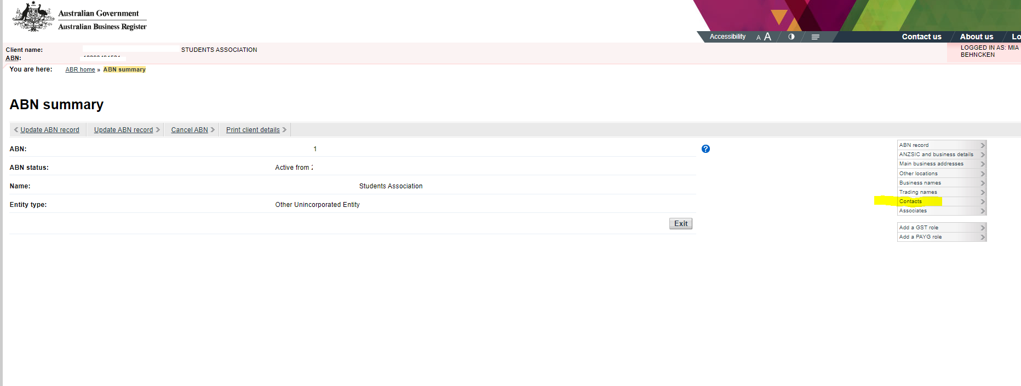As you are logged on with your My Gov ID and making changes, this should automatically log you in to your clubs ABN account with the ABR

- Select Contacts, Add new contact. This will then take you to a new page and select the contact tab. (see next page)
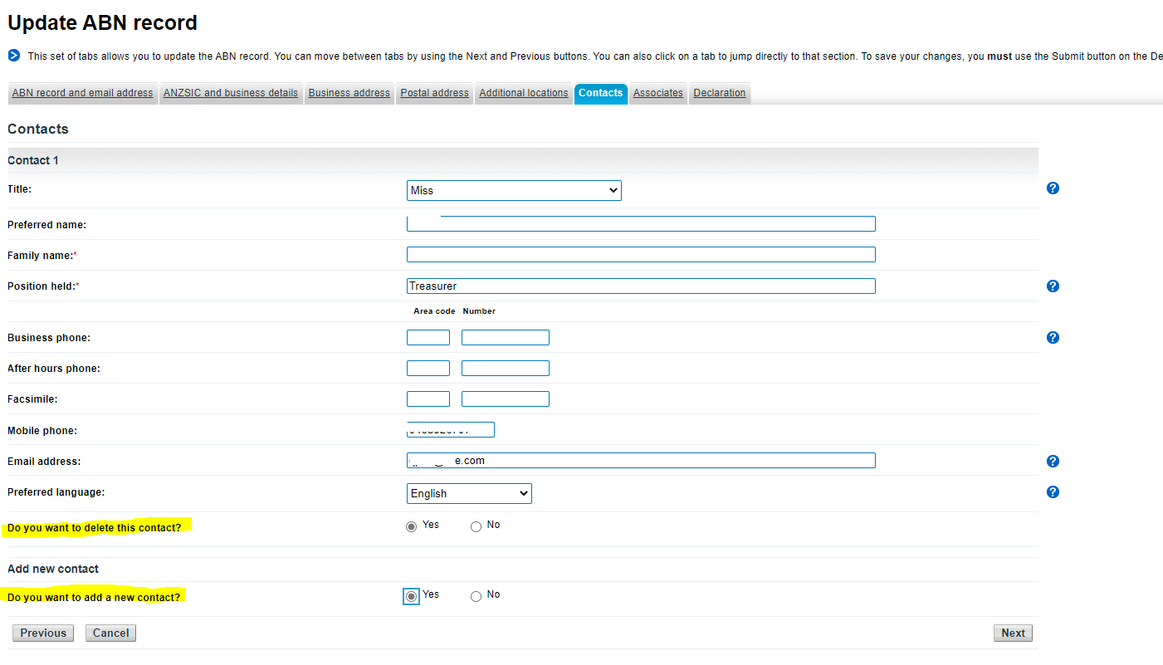

- Under contacts select YES delete this contact (on your current executive) and YES add new contact so you can add your new executive.

- You will need to add your new executive as a contact AND as an associate by clicking the associate tab – then add associate

- Once you have added your new exec as an associate you can now DELETE your current exec from the same tab
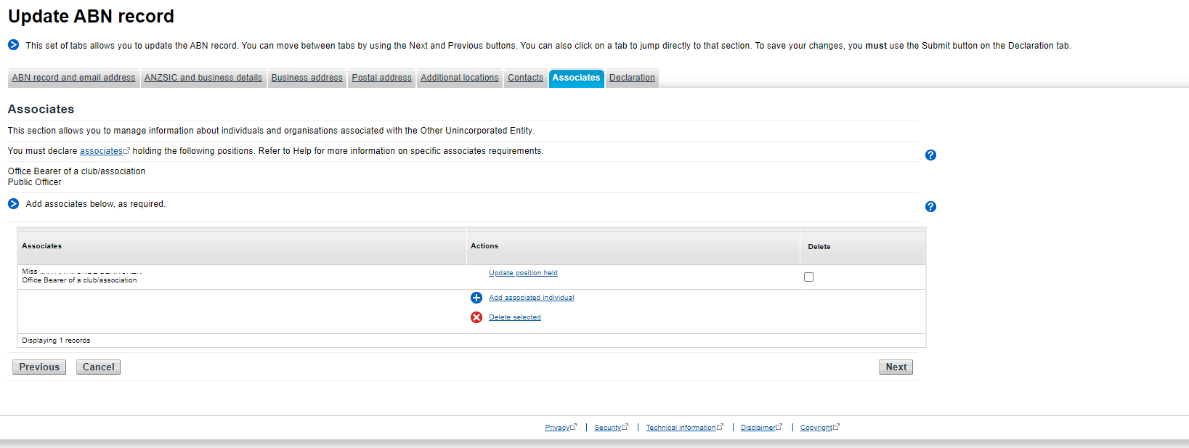

- Once you have added your new associate and deleted your old one, you can update the new and now current exec’s position held – to Office Bearer under the same tab

- You may have some errors appear, a common one is having to re-enter a contact email * remember to use your clubs email* and you will likely have to re-enter the business address (most likely the Union Address) it will not accept commas or brackets in the address ( or ,
The business activity may need to be updated: University club / society, social gatherings, social networking etc.

Lvl 4 Building 21 A UQ Union Complex
University of Queensland
St Lucia QLD
4072

- You can now return to MY GOV ID and delete your old executive.

